use anabig114231;

create external table building

(

BuildingID int,

BuildingMgr string,

BuildingAge int,

HVACProduct string,

Country string

)

row format delimited fields terminated by ',';

LOAD DATA INPATH '/user/anabig114231/building.csv' INTO TABLE building;

ALTER TABLE building

SET TBLPROPERTIES ("skip.header.line.count"="1");

select * from building;

create external table HVAC_tbl

(

Dote string,

Timee string,

Targetemp int,

Actualtemp int,

System int,

Systemage int,

BuildingID int

)

row format delimited fields terminated by ',';

LOAD DATA INPATH '/user/anabig114231/HVAC.csv' INTO TABLE HVAC_tbl;

ALTER TABLE hvac_tbl

SET TBLPROPERTIES ("skip.header.line.count"="1");

select * from hvac_tbl;

CREATE TABLE hvac_temperature AS

SELECT *, targetemp - actualtemp AS temp_diff,

IF((targetemp - actualtemp) > 5, 'COLD',

IF((targetemp - actualtemp) < -5, 'HOT', 'NORMAL')) AS temprange,

IF((targetemp - actualtemp) > 5, '1', IF((targetemp - actualtemp) < -5, '1', '0')) AS extremetemp

FROM hvac_tbl;

select * from hvac_temperature;

select * from hvac_temperature right join building on building.buildingid = hvac_temperature.buildingid;

## 1. Data Visualization/analysis by mapping the buildings that are mosr frequently outside of optimal temperature range. Calculate count of extremetemp by each country and temprange.

select country, count(extremetemp)

from hvac_temperature inner join building on building.buildingid = hvac_temperature.buildingid

group by country;

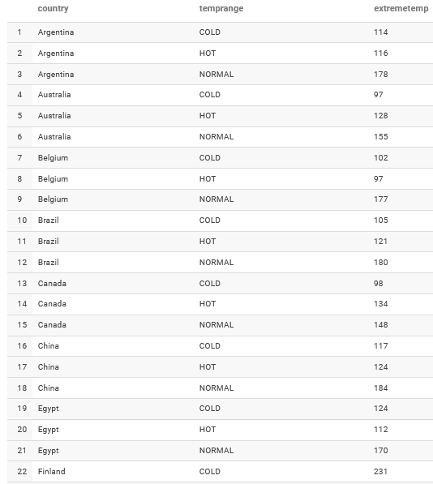

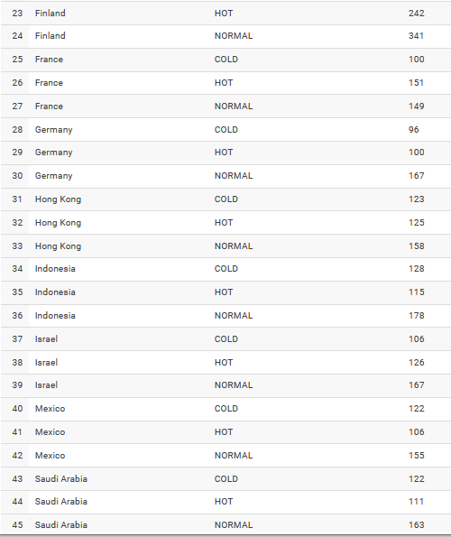

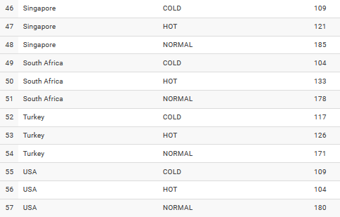

## 2. Which Country offices runs hot and which country offices runs cold . Calculate count of office run in hot and count of office run in cold by country.

select country, temprange,count(buildingmgr) as building

from hvac_temperature inner join building on building.buildingid = hvac_temperature.buildingid

group by country,temprange;

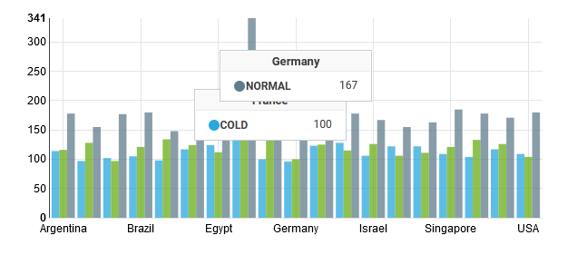

## 3. Our data set includes information about the performance of five brands of HVAC equipment, distributed across many types of buildings in a wide variety of climates. We can use this data to access the relative reliability of the different HVAC models. Calculate count of extremetemp by hvacproduct.

Select hvacproduct, count(extremetemp)

from hvac_temperature inner join building on building.buildingid = hvac_temperature.buildingid

group by hvacproduct;

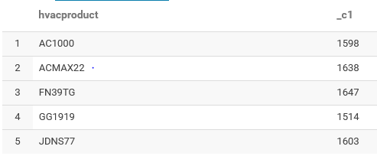

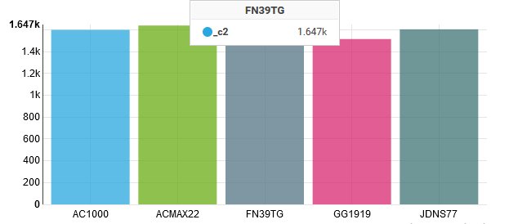

[http://npbdh.cloudloka.com:18088/](https://us06st1.zoom.us/web_client/1q1nf58/html/externalLinkPage.html?ref=http://npbdh.cloudloka.com:18088/)

I never saw a purple cow.

Gelett Burgess

I never saw a purple cow.

I never hope to see one.

But I can tell you, anyhow,

I'd rather see than be one!

[https://drive.google.com/file/d/1wqH26rrAdKtEJM8eHbNaIUeA_Fy6-Y1D/view?usp=sharing](https://us06st1.zoom.us/web_client/1q1nf58/html/externalLinkPage.html?ref=https://drive.google.com/file/d/1wqH26rrAdKtEJM8eHbNaIUeA_Fy6-Y1D/view?usp=sharing)